**Create a Splash Screen**

**Reference Link :** [**https://www.npmjs.com/package/react-native-splash-screen**](https://www.npmjs.com/package/react-native-splash-screen)

**Step 1**

Install Library

>>> npm i react-native-splash-screen

**Step 2**

Open **MainActivity.java**

**Android -> app -> src -> main -> java -> MainActivity.java**

And paste these lines of code into a **MainActivity.java**

import android.os.Bundle; // here

import org.devio.rn.splashscreen.SplashScreen; // here

@Override

protected void onCreate(Bundle savedInstanceState) {

SplashScreen.show(this); // here

super.onCreate(savedInstanceState);

}

Add like below image

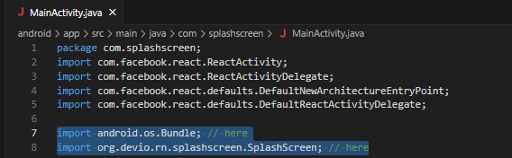

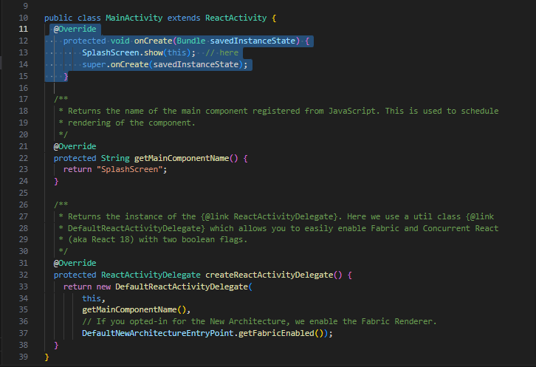

**Step 3**

Create **layout** folder inside a

Android 🡪 app 🡪 src 🡪 main 🡪 res 🡪 layout

And create **launch_screen.xml** file inside alayout folder

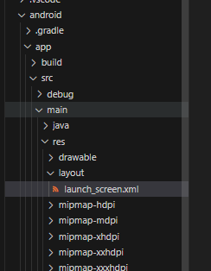

Add the given xml

<?xml version="1.0" encoding="utf-8"?>

<RelativeLayout xmlns:android="http://schemas.android.com/apk/res/android"

android:orientation="vertical" android:layout_width="match_parent"

android:layout_height="match_parent">

<ImageView android:layout_width="match_parent" android:layout_height="match_parent" android:src="@drawable/launch_screen" android:scaleType="centerCrop" />

</RelativeLayout>

Chaned the <ImageView> icon name as prt your image

Eg screen.png

<?xml version="1.0" encoding="utf-8"?>

<RelativeLayout xmlns:android="http://schemas.android.com/apk/res/android"

android:orientation="vertical" android:layout_width="match_parent"

android:layout_height="match_parent">

<ImageView android:layout_width="match_parent" android:layout_height="match_parent" android:src="@drawable/screen" android:scaleType="centerCrop" />

</RelativeLayout>

**Step 4**

Add Splash Screen Image in The Drawable folder

Create Basic Splash Screen with **(** **ape toole )**

**Link :** [**https://apetools.webprofusion.com/#/**](https://apetools.webprofusion.com/#/)

**Copy all generated Drawable**

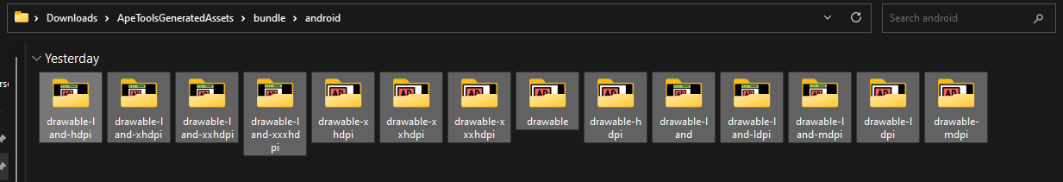

**And paste into Android -> app -> src -> main 🡪 res**

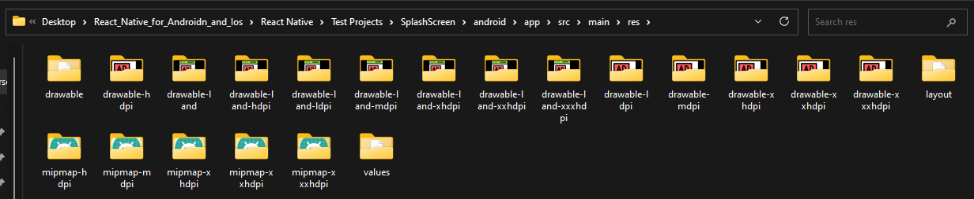

**Step 5**

**Open app.js**

**Import**

import SplashScreen from 'react-native-splash-screen'

**and use useEffect Hook**

import { StyleSheet, Text, View } from 'react-native'

import React, { useEffect } from 'react'

import SplashScreen from 'react-native-splash-screen'

const App = () => {

  useEffect(() => {

// do stuff while splash screen is shown

    // After having done stuff (such as async tasks) hide the splash screen

    SplashScreen.hide();

  }, [])

  return (

    <View>

      <Text>App</Text>

    </View>

  )

}

export default App

**>>> npx react-native start**